SDM COLLEGE OF ENGINEERING AND TECHNOLOGY, Dharwad-580002
(An autonomous institution affiliated to Visvesvaraya Technological University, Belgaum-590018)

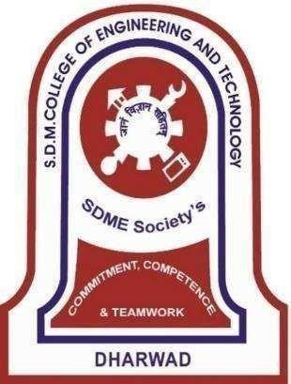

Department of Information Science and Engineering
6th SEMESTER B.E ACADEMIC YEAR: 2024-25 MINOR PROJECT - II

COURSE CODE: 22UISL605
“VoteSecure”

Under The Guidance Of

Prof. Varsha Jadhav
Submitted by,
RAHUL DHAGATI 2SD22IS032
SRUJAN ARAVALLI 2SD22IS053
SUJAL SOORYAVAMSHI 2SD22IS055
SUNIL RATHOD 2SD22IS057

SDM College of Engineering & Technology, Dharwad-580002

(An autonomous Institution affiliated to Visvesvaraya Technological University, Belagavi – 590018)
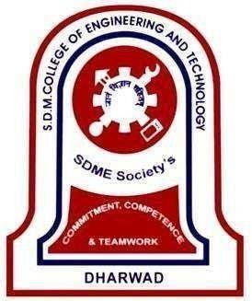

Department of Information Science and Engineering

CERTIFICATE

This is to certify that the Minor Project Phase II entitled "VoteSecure" is a bona fide work carried out by Mr. Rahul Dhagati, Mr. Srujan Aravalli, Mr. Sujal Sooryavamshi, Mr. Sunil Rathod bearing USN. 2SD22IS032, 2SD22IS053, 2SD22IS055, 2SD22IS057 respectively in successfully completing the project for V Semester B. E. Degree in Information Science and Engineering of S. D. M. College of Engineering, Autonomous Institution under Visvesvaraya Technological University, Belgaum during the year 2024-2025. It is certified that all necessary suggestion indicated for internal assessment have been incorporated. The project work has been approved as it has successfully satisfied the academic requirements.

Prof. Varsha Jadhav | Prof. Varsha Jadhav | Dr. Jagadeesh Pujari | Dr. Ramesh L Chakrasali
Project Guide | Project Co-ordinator | HOD ISE | Principal

 | Examiner 1 | Examiner II
Signature with date
Name

